MELBOURNE JUNIOR SCHOOL
SCHOOL UNIFORM POLICY
2026 - 2027

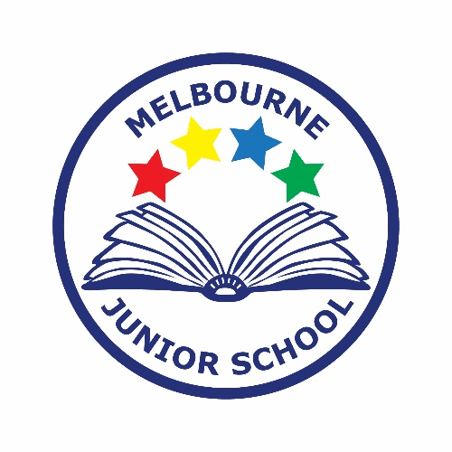

Approved by: | Full Governing Board | Date: 20/07/2026
Last reviewed on: | 31/03/2025
Next review due by: | March 2028

Contents
1. Aims 2
2. Our school’s legal duties under the Equality Act 2010 2
3. Limiting the cost of school uniform 3
4. Expectations for school uniform at Melbourne Junior School 3
5. Expectations for our school community 4
6. Monitoring arrangements 5
7. Links to other policies 5

1. Aims
This policy aims to:
- Set out our approach to requiring a uniform that is of reasonable cost and offers the best value for money for parents and carers
- Explain how we will avoid discrimination in line with our legal duties under the Equality Act 2010
- Clarify our expectations for school uniform

2. Our school’s legal duties under the Equality Act 2010
The Equality Act 2010 prohibits discrimination against an individual based on the protected characteristics, which include age, sex, disability, race, religion or belief, pregnancy and maternity, and gender reassignment.
To avoid discrimination, our school will:
- Avoid listing uniform items based on sex, to give all pupils the opportunity to wear the uniform they feel most comfortable in or that most reflects their self-identified gender.
- Make sure that our uniform costs the same for all pupils.
- Allow all pupils to have long hair (though we reserve the right to ask for this to be tied back) and to style their hair in a way that is appropriate to and safe in a school setting.
- Allow pupils to request changes to swimwear for religious reasons or if they are experiencing discomfort related to their sex, gender or gender reassignment.
- Allow pupils to wear headscarves and/or other religious garments.
- Allow pupils with sensory or physical needs to make reasonable adaptations to their uniform depending on their specific needs.
- Allow for reasonable adaptations to our policy on the grounds of equality by asking pupils or their parents to get in touch with the Headteacher, who can answer questions about the policy and respond to any requests. These will be considered on a case-by-case basis.

3. Limiting the cost of school uniform
Our school has a duty to make sure that the uniform we require is affordable, in line with statutory guidance from the Department for Education on the cost of school uniform.
We understand that items with distinctive characteristics (such as branded items, or items that have to have a school logo or a unique fabric/colour/design) cannot be purchased from a wide range of retailers and that requiring many such items limits parents’ ability to ‘shop around’ for a low price.
We will make sure our uniform:
- Is available at a reasonable cost
- Provides the best value for money for parents/carers
We will do this by:
- Carefully considering whether any items with distinctive characteristics are necessary.
- Limiting any items with distinctive characteristics where possible.
- Limiting items with distinctive characteristics to low-cost and/or long-lasting items.
- Considering cheaper alternatives to school-branded items, such as logos that can be ironed on, as long as this doesn’t compromise quality and durability
- Avoiding specific requirements for items pupils could wear on non-school days, such as coats, bags and shoes
- Keeping the number of optional branded items to a minimum, so that the school’s uniform can support social equality
- Avoiding different uniform requirements for different year/class/house groups
- Avoiding different uniform requirements for extra-curricular activities
- Considering alternative methods for signalling differences in groups for interschool competitions, such as creating posters or labels
- Making sure that arrangements are in place for parents to acquire second-hand uniform items
- Avoiding frequent changes to uniform specifications and minimising the financial impact on parents of any changes
- Consulting with parents and pupils on any proposed significant changes to the uniform policy and carefully considering any complaints about the policy

4. Expectations for school uniform at Melbourne Junior School
4.1 Our school’s uniform requirements

Clothing:
Melbourne Junior School uniform is navy blue and grey
Navy blue jumper or cardigan.
White polo shirt
Grey trousers, shorts, skirt or pinafore dress
Navy blue and white check school dresses may be worn in the summer
Flat black shoes, or plain black trainers.

For PE lessons, the required clothes are:
A coloured T-shirt which matches the house team the child is in
Sports trainers
Tracksuit trousers
A navy blue school jumper or cardigan should be worn. We do not allow hooded sweatshirts for PE.
School bags should be small and easy to store.
Hair:
Both boys and girls may have long hair, but this should be tied back away from the face.
Children should style their hair in a way that is appropriate to a school setting and to be neat and safe.
Hairstyles which are extreme, including hairstyles where the sides are much shorter than the top / back or where lines and patterns are shaved into the hair, are not recommended.
Hair accessories should be kept small and to a minimum.

Jewellery:
Children may wear small stud earrings.
Earrings must be removed or taped for PE and sport.
Children may wear a watch (we request that smart watches are not worn).

We request that children do not wear make-up or nail varnish/false nails to school.

If parents require adaptations to school uniform for their child on the grounds of Special Educational Needs, Protected Characteristics or religion, they should contact the Headteacher. These will be considered on a case-by-case basis.

4.2 Where to purchase it
Melbourne Junior School uniform items with the school logo can be purchased from:
Pupils Schoolwear, 35 West Street, Swadlincote, Derbyshire. DE11 9DN Tel: 01283 224512
https://pupilsschoolwear.co.uk/home/

The school holds a large quantity of good quality second-hand uniform, this is available to view via the school office.

5. Expectations for our school community
5.1 Pupils
Pupils are expected to wear the correct uniform at all times (other than specified non-school uniform days) while:
- On the school premises
- Travelling to and from school

Parents and pupils are also expected to contact the Headteacher if they want to request an amendment to the uniform policy in relation to their protected characteristics.

5.2 Parents and carers
Parents and carers are expected to make sure their child has the correct uniform and PE kit, and that every item is:
- Clean
- Clearly labelled with the child’s name
- In good condition
Parents are also expected to contact the Headteacher if they want to request an amendment to the uniform policy in relation to:
- Their child’s protected characteristics
- Special Educational Needs
- The cost of the uniform
Parents are expected to lodge any complaints or objections relating to the school uniform in a timely and reasonable manner.
Disputes about the cost of the school uniform will be:
- Resolved locally
- Dealt with in accordance with our school’s complaints policy
The school will work closely with parents to arrive at a mutually acceptable outcome.
5.3 Staff
Staff will closely monitor pupils to make sure they are in correct uniform. They will give any pupils and families breaching the uniform policy the opportunity to comply but will follow up with the headteacher if the situation doesn’t improve.
Ongoing breaches of our uniform policy will be dealt with by the Headteacher in conjunction with the Melbourne Junior School Behaviour policy.
In cases where it is suspected that financial hardship has resulted in a pupil not complying with this uniform policy, staff will take a mindful and considerate approach to resolving the situation.
5.4 Governors
The governing board will review this policy and make sure that it:
- Is appropriate for our school’s context
- Is implemented fairly across the school
- Takes into account the views of parents and pupils
- Offers a uniform that is appropriate, practical and safe for all pupils
The board will also make sure that the school’s uniform supplier arrangements give the highest priority to cost and value for money, for example by avoiding single supplier contracts and by re-tendering contracts at least every 5 years.

6. Monitoring arrangements
This policy will be reviewed every two years by the Headteacher and Business Officer. At every review, it will be approved by the Full Governing Board.

7. Links to other policies
This policy is linked to our:
- Behaviour policy
- Equality information and objectives statement
- Anti-bullying policy
- Complaints policy

